Glossary - Module 1 Course 5 Risk Management

Business Risk

Risk of changes to a business that are unexpected such as a sudden drop in revenues because a key customer has signed with a competitor. Business risk can be internal such as producing poor quality products, violations of law, and unethical business practices. External sources of business risk can come from new competitors, suppliers, customers and regulatory agencies. Some business risk can be unique to the company such as brand recognition, market leadership or the company’s overall reputation.

Derivatives

Financial instruments usually in the form of a contract whose price is derived from another asset such as a Futures Contract for the delivery of commodities at a future date and at a specified price. Derivatives are used to hedge and protect against price changes in the future. However, many investors buy and sell derivatives such as stock options through exchanges. Investors are betting against uncertainty with prices by trading in derivatives. External Wiki Page

Enterprise Risk Management

The implementation of a complete risk management process across all parts of an organization using a set of standard practices such as a well-defined procedure for identification of risks. Some practices are very mature such as specific procedures on quantification of risk. Additionally, the risk management process is elevated in terms of importance by having a designated risk management committee and officer at the highest levels of the organization. The goal is to make the management of risk a core competency of the organization.
External Wiki Page

Hedging

An investment strategy that attempts to offset the risk of losses from another investment. For example, an investment contract requires the purchase of a commodity at a future price. You can offset or hedge against this investment by entering into another investment that allows you to sell the commodity through a futures contract. You can sell the futures contract to offset your potential loss from purchase side of the investment. Another example would be to take both a long and short position on a security. Therefore, hedging tends to reduce risk when you have uncertainty over future prices. However, hedging also cuts into your opportunity for profits since you are taking an opposite and equal position using two strategies. External Wiki Page

Risk

The likelihood that some event will take place having a negative and/or positive impact on your business. Almost every decision has some implied risk associated with it. There is always a chance that what you expect to happen will not actually happen. There are all kinds of risk – risk of default (not making payments), risk of lawsuits, risk of product defects, risk of new competition, risk of investment returns not meeting expectations, etc. All businesses should have a process of identifying and managing their risk. External Wiki Page
Risk Analysis

A process of evaluating and analyzing your risks qualitatively and quantitatively. Qualitative risk analysis usually tries to describe the risk in terms of how severe it could be to the company. Quantitative risk analysis includes the specific values you have assigned to the risk such as a value to the loss or the probability of occurrence given past events. Most risk include some form of descriptive type information (qualitative factors). More serious risk require the application of specific quantitative risk techniques such as Monte Carlo in an attempt to assign the potential loss if the risk event were to occur. External Wiki Page

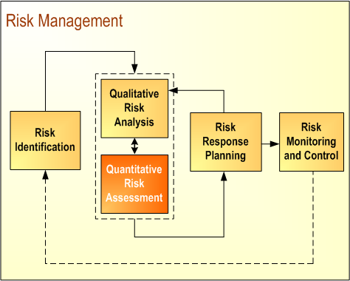

Risk Control

The various procedures, practices and policies that a company implements to properly manage its risks. Risk control usually involves monitoring and tracking risks over time. This information may get consolidated through the use of a Risk Register. Therefore, the Risk Register can represent an important focal point in the risk control process.

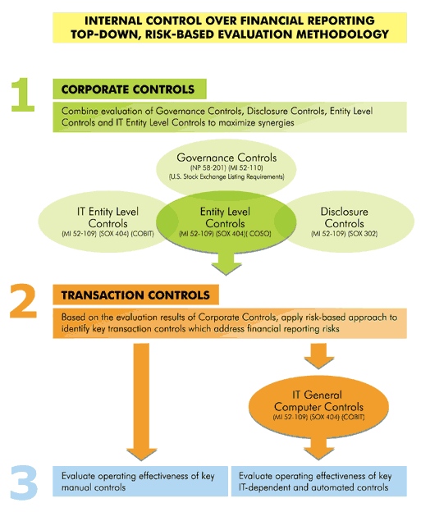

Risk Free Rate

The minimal rate of return associated with an investment that has no risk of default. For example, Certificates of Deposit or Government Securities are guaranteed to pay interest. This interest rate is a risk free rate of return. The expectation is that the minimal risk free rate of return will at least cover inflation or the cost of living adjustments in the future. Therefore, a risk free rate is often relative to what the inflation rate is. External Wiki Page

Risk Mitigation

Some type of action taken to reduce a potential risk such as backing up your data on your computer in the event you have a hard disk crash. Risk mitigations usually are a “middle of the road” (see yellow range in chart below) response to risk where accepting risk with no action is at one extreme and avoiding the risk altogether is at the opposite extreme. Therefore, risk mitigation is a very common practice for addressing a wide range of risks. For example, you may want to implement a succession plan for critical employees to “mitigate” against lost productive time in the event you lose critical employees. A beach side resort “mitigates” against weather events by constructing a dike and levy system around the perimeter of the resort structure. There are all kinds of mitigations you develop for addressing various risks.

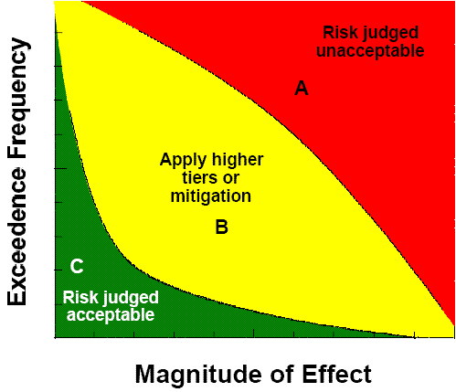

Risk Parameters

Attributes used to help control and properly manage risks. For example, once you reach a certain threshold, you trigger an action to manage a risk. Many risk are evaluated in terms of some parameter such as the likelihood of occurrence and different severity levels. Once a risk crosses these thresholds, the risk gets categorized or ranked a certain way. Risk registers and risk models often include numerous parameters such as type of risk. Basel II includes parameters such as Default Probability, Loss Given Default and Exposure at Default.

Risk Premium

Additional returns that are expected above the risk free rate associated with the investment. There is no real risk for holding an investment in money market certificates in the Bank. However, there are much higher risk for holding an investment in a company that is just starting out. There is a very high probability that the company will not survive and you will never realize any return on your investment. The additional risk of how an investment might perform relative to the risk free rate is represented by the risk premiums. A simple risk premium might involve the fact that you have invested in low grade corporate bonds and there is a risk premium associated with default; i.e. the debtor may not be able to pay back the investment. External Wiki Page

Risk Profile

An overall rating or description of how a company views and manages its various risk. For example, a simple risk rating system may categorize risk and once all risk are categorized, the company takes certain types of actions. This information conveys the risk profile of the company. In personal finance, people are often asked a series of questions to determine their risk profiles – such as a willingness to take risk as a "conservative" investor, a "moderate" investor or an "aggressive" investor.

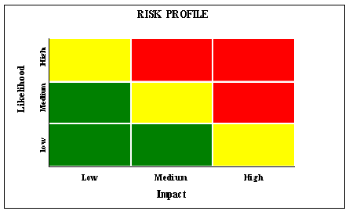

Risk Register

An important tool for capturing and managing each individual risk. A simple risk register might look similar to a spreadsheet with each row representing a risk and each column providing important attributes associated with the risk such as an identification number, description, who the risk is assigned to, when was it first recorded, when was it last updated, what is the risk response strategy, and what risk rating has been assigned. In order to have an effective risk register it is usually necessary to have only a few specialist assigned to maintaining the risk register; otherwise too many people result in inconsistent information and application of how the risk register works. You also need to set some ground rules on what gets included in the risk register. For example, some risk are acceptable and not worth monitoring through the risk register. External Wiki Page

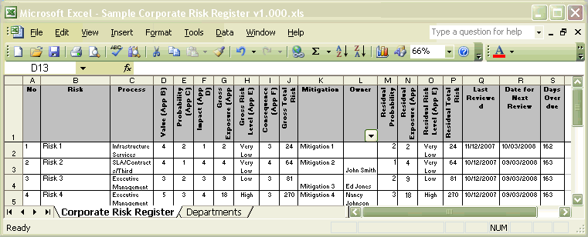

Risk Response

A decision or set of actions taken to manage an identified risk. Usually takes the form of acceptance, avoidance, mitigation or transfer. For example, you simply make a decision to accept the risk because its potential impact is so low and the probability of its occurrence is extremely low. In another case you develop a mitigation strategy to reduce the impact. Where the potential impact is significant, but probability is low your risk response is to transfer the risk to another party (usually takes the form of insurance).

Risk Tolerance

A level of risk that you are willing to accept as part of doing business. Some risk you recognize, but must manage. Other types of risk are too significant and you do not include these as part of your business objectives. For example, your company may not have the capabilities to make an important investment in an international market; so you decide not pursue this investment because you cannot absorb this loss. However, you are willing to tolerate domestic investments since you have the capabilities to execute these investments with reasonable success. Risk tolerance often boils down to your willingness to accept certain conditions as part of realizing gains; i.e. the risk return tradeoff. Investors are often categorized as aggressive, moderate or conservative. Aggressive investors have a much higher risk tolerance than conservative investors. External Wiki Page

Speculation

An aggressive investment strategy that runs contrary to the consensus of most investors, but can potentially realize significant profits. This type of investment strategy often requires very mature insights into how companies and markets work. For example, venture capitalist tend to invest in startup companies that have high probabilities of failure. However, venture capitalist also have considerable business savvy on what can work and cannot work in creating new markets. Speculation involves high risk of failure, but when speculation is successful, there are high returns. Unlike hedging which attempts to reduce price fluctuations, speculation tends to gamble on major price fluctuations. External Wiki Page

Swaps

A derivative type contract whereby two parties exchange cash flows in an effort to better manage risk. For example, one party may have outstanding debt that involves a floating interest rate. In an effort to reduce risk, the party decides to enter into a interest rate swap which locks-in a fixed interest rate while another party is hedging against moves in interest rates through a floating rate. Another form of swap is to exchange obligations denominated in different currencies. Unlike interest rate swaps which do not involve principal amounts, currency swaps do involve a principal amount. External Wiki Page

Value at Risk

Assigning a value to the total potential loss you could incur with a portfolio of tradable securities. The Value at Risk amount is usually measured for a short period of time such as 1 to 5 days since financial institutions rarely hold securities for the long-term. The Value at Risk amount is expressed at different confidence levels. Most institutions choose a confidence level of 95% or 99%. For example, suppose you have a Value at Risk Amount of $ 20 Million for 3 days at 95%. This indicates that by holding the securities for 3 days, you are 95% confident that your loss could be as high as $ 20 million. External Wiki Page

