Glossary Content – Module 1 Course 4 Fundamentals of Corporate Finance (Part 2)

Analogous

An approach to estimating costs and / or revenues by making comparisons to something that is very similar to what it is you are trying to measure. For example, you may need to estimate the cost of building a new house and houses that are very similar were built for around $ 350,000. The analogous approach often relies on expert opinions of others. The analogous approach to estimation is considered a quick and fast way of developing an estimate that is not expected to be highly accurate. As you learn more and work through the project or investment, you should adjust and revise your estimate for increased accuracy.

Annuity

An amount of money that is paid out on a consistent basis over an extended period of time. Annuities help secure a steady cash flow such as assisting retired people with meeting their regular living expenses in the absence of work related income. Annuities are sold by insurance companies. An annuity that has a guaranteed payment is referred to as a Fixed Annuity and an annuity that pays out according to the performance of the investments involved is referred to as a Variable Annuity. External Wiki Page

Arbitrage

An investment activity that both buys and sells an investment because two markets with the same identical investment are priced differently. For example, an investor may buy a commodity in one market at a low price and sell the same commodity at a higher price in another market. This type of investment activity tends to force some equalization between the two markets; i.e. price disparities are reduced between the two markets. Arbitrage buying and selling is very common with foreign currencies since there are several markets for most currencies and each market can experience differences. Arbitrage trading can also happen when one company decides to acquire another company. Arbitrageur’s start to buy stock of the target company with the expectation that the final price paid will be higher. External Wiki Page

Breakeven Analysis

A methodology of distinguishing costs between variable and fixed so that you can calculate a breakeven amount or volume of sales. The breakeven point is the amount you need to generate in order to recover all of your fixed and variable costs. You can work with certain variables such as pricing of products or volume sold to see what you have to do just to breakeven. An example of a breakeven calculation appears below:

Step 1: Total Fixed Costs = $ 150,000

Step 2: Establish Your Sales Price per Unit = $ 30.00

Step 3: Identify Your Variable Cost per Unit = $ 20.00

Step 4: Divide the Contribution Margin (Sales Price – Variable Cost) into the Fixed Costs = $ 150,000 / ($ 30.00 - $ 20.00) = 15,000 units must be sold to breakeven. This equates to total revenues of $ 450,000 less fixed costs of $ 150,000 less variable cost of $ 300,000 ($ 20.00 x 15,000) = $ - 0 –
External Wiki Page

Business Risk

Risk of changes to a business that are unexpected such as a sudden drop in revenues because a key customer has signed with a competitor. Business risk can be internal such as producing poor quality products, violations of law, and unethical business practices. External sources of business risk can come from new competitors, suppliers, customers and regulatory agencies. Some business risk can be unique to the company such as brand recognition, market leadership or the company’s overall reputation.

Cost Benefit Analysis

A formal evaluation of different investment alternatives in an effort to objectively select the best alternative. Criteria for selecting the best alternative can include both economic and non-economic criteria. Economic criteria usually include the calculation of Net Present Value for each alternative. Non Economic criteria include qualitative factors that help a business meet important objectives such as regulatory compliance.

A good Cost Benefit Analysis will include background information about the investment such as why the investment is important to the company, what is the expected outcome from the investment, what is the life of the investment, who will manage the investment, and what risk are involved.
External Wiki Page

Derivatives

Financial instruments usually in the form of a contract whose price is derived from another asset such as a Futures Contract for the delivery of commodities at a future date and at a specified price. Derivatives are used to hedge and protect against price changes in the future. However, many investors buy and sell derivatives such as stock options through exchanges. Investors are betting against uncertainty with prices by trading in derivatives. External Wiki Page

Financial Leverage

The use of debt financing to sustain and grow a business. When a business borrows money, it is using financial leverage. As a business uses more financial leverage (borrows more money), it must have sufficient cash flows to service the interest and principal payments it must make. Unlike Operating Leverage which is measured in terms of its impact on Operating Income, Financial Leverage is measured in terms of its impact on Net Income.
External Wiki Page

Futures

A type of derivative contract that involves the delivery of products in the future at an agreed to price today. Futures are traded on exchanges which enforces each party to meet its obligations. For example, initial collateral must be provided by the buyer to enter into the futures contract. Futures may involve commodities such as sugar, wheat, or soy beans. When commodities are involved, the futures contract will include quality of performance standards that must be met. Most future contracts also designate the size or lot involved, such as 500 ounces of gold for a gold futures contract. External Wiki Page

Hedging

An investment strategy that attempts to offset the risk of losses from another investment. For example, an investment contract requires the purchase of a commodity at a future price. You can offset or hedge against this investment by entering into another investment that allows you to sell the commodity through a futures contract. You can sell the futures contract to offset your potential loss from purchase side of the investment. Another example would be to take both a long and short position on a security. Therefore, hedging tends to reduce risk when you have uncertainty over future prices. However, hedging also cuts into your opportunity for profits since you are taking an opposite and equal position using two strategies. External Wiki Page

Horizontal Integration

The integration of different business units into one larger company so that shared services can be leveraged and duplicative processes can be reduced. Horizontal integration often arises because there is one common ownership over several companies, often as a result of mergers and acquisitions. Horizontal integration usually attempts to consolidate common services such as human resource management, finance, risk, information technology and other support functions in an effort to eliminate duplicative activities. External Wiki Page

Level of Effort

Quantifying the amount of work that is required to complete a task, activity, or larger component of work. Levels of effort typically involve labor costs which is a function of hours and rates. Most levels of effort are estimated around some specific outcome, work product or deliverable. This is often the case with project related work. For example, a new addition to your house is a major project and this will involve a certain level of effort on the part of contractors. The contractors will work up a level of effort estimate and submit their proposed costs to you for consideration.

Market Risk

Risk of changes to the value of an investment given changes in the market. Market risk often come in four forms:

- Equity Risk – Risk of changes to the price of stocks. This risk is often measured using a Beta Coefficient.
- Interest Rate Risk – Risk of changes to the price of bonds or other assets given changes to interest rates.
- Currency Risk – Risk of changes to the value of a currency given changes in the exchange rates with other currencies.
- Commodity Risk – Risk of changes in commodity prices (sugar, wheat, metals, etc.) with changes to supply and demand.
External Wiki Page

Operating Leverage

The use of higher fixed costs relative to variable costs in generating higher operating income. Businesses that invest heavily in permanent facilities must sell sufficient products to cover their fixed costs. As the business sells more and more, the contribution to operating income goes up much higher than if the company had mostly variable costs involved. For example, a computer chip manufacturer has significant fixed cost invested in very high-tech facilities. It is important to recover this large investment by selling computer chips. Once the company recovers its fixed costs, the additional chips that are sold yield very high margins since the variable costs are so low. Operating leverage is measured in terms of its impact on Operating Income.
External Wiki Page

Optimal Capital

The mix of debt and equity that forms the capital structure of a company at the lowest overall weighted average cost of capital and at the same time maximizes the earnings of the company. Finding this optimal capital mix is more applicable to publicly traded companies which often have easier access to capital. Private companies have to jump from one source to the other depending upon what they can arrange given the higher risk involved. Therefore, it can be much more challenging for a private company to find an optimal capital mix. An equity recapitalization is sometimes required whereby new equity investors are willing to fund future growth of the business.
External Wiki Page

Options

A type of derivative security that gives the investor the option of either buying or selling a security or a commodity at a specific price on or before a specific date. The purpose of options is to give the investor additional leverage in how the investor can hedge (reduce risk) against price movements in the future. Two types of stock options are Puts and Calls. A Put Option gives the investor the right to sell shares of stock at a striking price prior to when the option expires. A Call Option gives the investor the right to buy shares of stock at a striking price before expiration of the option. If you think the market will go down (securities are over-priced), then you would consider using Puts and if you think underlying assets are under-priced, then you would tend to use Calls.
External Wiki Page

Parametric

An approach to developing an estimate (usually costs) that relies on specific measures as the basis behind the estimate. You can infer what the cost will be based on these metrics that are often rooted in past historical data such as durations or unit cost. For example, the average hourly labor rate is $ 65.00. We can use this rate of $ 65.00 and apply it to our future expected hours of work to estimate what the cost of work. Sizing parametrics are very common such as the cost per square foot or cost per finished product. Parametrics are used in mathematical equations or functions that serve as the inputs behind the estimates. Parametrics are also supported with the application of statistics such as the most probable unit cost is $ 26.50 per final product based on a random sample of historical data.
External Wiki Page

Perpetuity

A stream of cash flows that will extend indefinitely with no termination in the future. The concept of a perpetuity is sometimes applied where you have to assign a value to an investment that you do not expect to liquidate or sell at any point in the future. For example, if you acquire a new business that has been in existence for an extremely long time, then you may want to simply look at the net cash flows from this business as a perpetuity. This concept is often applied to a stock that has a past history of consistently paying a dividend. Therefore, the value of the stock is simply the expected dividend divided by the rate of return adjusted for any growth rate.
External Wiki Page

Portfolio

The grouping of investments, assets or other resources to facilitate a high level view of how to best manage all of the investments. Once you have grouped your investments into a portfolio, you can evaluate and assess your overall portfolio risk and returns. You can establish your performance objectives, targets and other priorities to meet your final goals. Large investment holdings have Portfolio Managers who are constantly assessing the performance of the portfolio against the overall goal of the portfolio. For example, the goal of one portfolio might be modest growth without too much volatility. If one of the investments within the portfolio fails to meet this goal, the Portfolio Manager will most likely remove this investment from the portfolio. Therefore, the assets that comprise a portfolio are changing over time.
External Wiki Page

Private Capital

The funding of a business from private sources such as Private Equity Groups, Investment Bankers, Angel Investors, and Venture Capitalist. Each private source of capital has its own requirements when funding a business. For example, an Angel Investor may get involved in a small startup company, providing not just funding but also management expertise. The Angel Investor is a highly successful entrepreneur who is no longer building other companies, but is willing to lend expertise and money to help a new company become successful. Private capital tends to work “deal to deal” and each deal is arranged differently with its own unique valuation. Contrast this with public companies that go to a centralized and efficient market for raising capital.
External Wiki Page

Probability Distribution

A table that depicts the probabilities of outcomes over some range of values. A probability distribution can take two forms:

Discrete Values: Only specific values are measured; i.e. it is very black and white as to what the range of values are such as a rating between 1 (poor) to 5 (excellent). The next step is to take a sample and show how the values are distributed, such as 8 people rated the course as 5 (excellent) out of a total of 20 people sampled. The probability that people will rate this course as excellent is 40% (8 / 20).

Continuous Values: Almost any value can come up within the range such as a person’s weight. One person may weigh 212.6 pounds while a baby only weighs 6.3 pounds. The probability of meeting someone who weighs 212.6 pounds or 6.3 pounds is essentially zero.

A frequency distribution is often used to describe how the data is distributed such as the following:

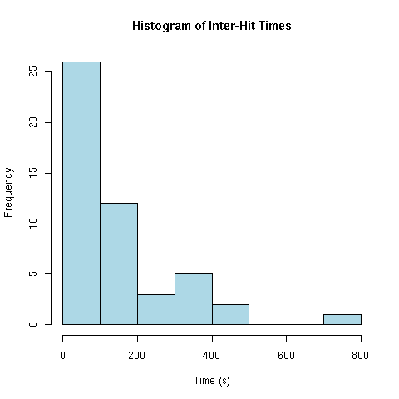

External Wiki Page

Risk

The likelihood that some event will take place having a negative and/or positive impact on your business. Almost every decision has some implied risk associated with it. There is always a chance that what you expect to happen will not actually happen. There are all kinds of risk – risk of default (not making payments), risk of lawsuits, risk of product defects, risk of new competition, risk of investment returns not meeting expectations, etc. All businesses should have a process of identifying and managing their risk. External Wiki Page

Risk Free Rate

The minimal rate of return associated with an investment that has no risk of default. For example, Certificates of Deposit or Government Securities are guaranteed to pay interest. This interest rate is a risk free rate of return. The expectation is that the minimal risk free rate of return will at least cover inflation or the cost of living adjustments in the future. Therefore, a risk free rate is often relative to what the inflation rate is. External Wiki Page

Risk Premium

Additional returns that are expected above the risk free rate associated with the investment. There is no real risk for holding an investment in money market certificates in the Bank. However, there are much higher risk for holding an investment in a company that is just starting out. There is a very high probability that the company will not survive and you will never realize any return on your investment. The additional risk of how an investment might perform relative to the risk free rate is represented by the risk premiums. A simple risk premium might involve the fact that you have invested in low grade corporate bonds and there is a risk premium associated with default; i.e. the debtor may not be able to pay back the investment. External Wiki Page

Speculation

An aggressive investment strategy that runs contrary to the consensus of most investors, but can potentially realize significant profits. This type of investment strategy often requires very mature insights into how companies and markets work. For example, venture capitalist tend to invest in startup companies that have high probabilities of failure. However, venture capitalist also have considerable business savvy on what can work and cannot work in creating new markets. Speculation involves high risk of failure, but when speculation is successful, there are high returns. Unlike hedging which attempts to reduce price fluctuations, speculation tends to gamble on major price fluctuations.
External Wiki Page

Standard Deviation

A measure of how much dispersion takes place around the mean (average) in the distribution of data. A low standard deviation indicates that a lot of the data is clustered around the mean (see the red line curve below). A high standard deviation indicates that you have a much wider dispersion of data away from the mean (see red line curve below).

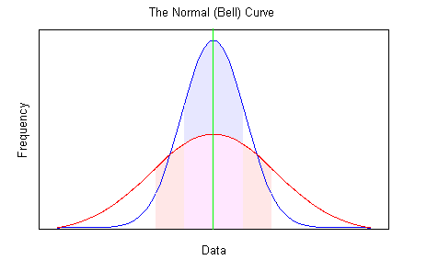

As it relates to finance, a high standard deviation would imply higher risk since you have more variation from the average. For example, if the average return for investments is 8% and you have a standard deviation of 3%, then you can expect to earn between 5% and 11% around 68% of the time. If you increase the standard deviation to 6% (2 standard deviations), then you can expect to earn between 2% and 14% around 95% of the time.
External Wiki Page

Sunk Cost

Cost that are already incurred and not relevant to an investment decision. For example, you decide to undertake a feasibility study to determine if a major project is possible given your capabilities. The cost of the feasibility study is $ 100,000. This cost is sunk since it is incurred regardless if you make the decision or not. Some industries such as the pharmaceutical industry invest heavily in research and development. This cost is expensed as a part of doing business. It is difficult to link or align these types of cost to a specific product, project, or other cost object.
External Wiki Page

Swaps

A derivative type contract whereby two parties exchange cash flows in an effort to better manage risk. For example, one party may have outstanding debt that involves a floating interest rate. In an effort to reduce risk, the party decides to enter into a interest rate swap which locks-in a fixed interest rate while another party is hedging against moves in interest rates through a floating rate. Another form of swap is to exchange obligations denominated in different currencies. Unlike interest rate swaps which do not involve principal amounts, currency swaps do involve a principal amount. External Wiki Page

Transfer Channel

A channel selected by a private business owner to transfer ownership to another party. Private companies use one or more of these transfer channels to change the ownership of the company. For example, a business owner may want to transfer part of his ownership to an investment banker who will ultimately help sell the company to another company. Each transfer channel has its own valuation process. In some cases the private business owner may want to exercise a charitable trust as a means of transferring or reducing the ownership investment since the business owner wants to give back to society. Therefore, the nature of transfer channels is determined by what the business owner wants to accomplish. The following illustration taken from the book Private Capital Markets by Robert T. Slee shows the various transfer channels:

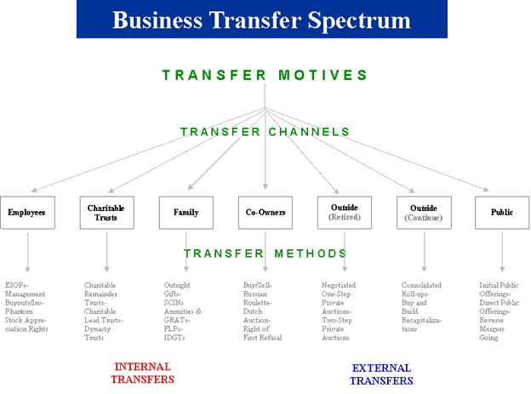

Vertical Integration

The integration of processes from the top to the bottom such as suppliers of raw materials, distribution points, manufacturing facilities, retail outlets, and customers. Supply chain management usually represents the over-arching process to manage vertical integration. The advantages of achieving vertical integration is to establish a reliable and standard process from end to end. This can be critically important for businesses that have steady growth and demand for their products. External Wiki Page

Weighted Average Cost of Capital

The application of book value or market values to components of capital in an effort to arrive at an overall weighted cost of capital for the business. The Weighted Average Cost of Capital or WACC represents an important benchmark for measuring if long-term investments will increase the value of a business. You need to make long term investments whereby the return on investment exceeds the WACC. In order to calculate WACC you will need to assign weights to the interest bearing debt and the total amount of equity invested. For example, if the market value of interest bearing debt is $ 180,000 and the market value for equity investments is $ 270,000, then you would assign a 40% weight ($ 180,000 / $ 450,000) to the debt component and a 60% weight ($ 270,000 / $ 450,000) to the equity component. Your next step would be to calculate your after tax interest rate for debt. For example, if your interest rate on long term loans is 8% and your tax rate is 30%, then your after tax rate is 5.6% (8% x .70). Next you have to measure what the cost of equity is; i.e. how much return do I have to pay my owners? Suppose you are required to return 15% to your owners. You can now apply weights to both your debt component and equity component to arrive at your WACC. In our example this would be:

Debt Component = .40 x 5.6% = 2.24%
Equity Component = .60 x 15.0% = 9.00%

Finally, sum up the two weighted components to arrive at the WACC. This gives you a WACC of 11.24%.

