Glossary – Module 1 Course 3 Fundamentals of Corporate Finance (Part 1)

Beta Coefficient

A measure of stock price volatility in relation to changes to the market. A beta coefficient expresses the degree of correlation between the price of the security in relation to the market. A beta coefficient of 1.0 would imply that the price of the security moves exactly with the market. A beta coefficient of .5 indicates that the price moves at 50% of the market price change. The higher the beta coefficient, the higher the risk of the security in relation to the market. The beta coefficient is used as part of the Capital Asset Pricing Model for calculating the Cost of Capital.
External Wiki Page

Economic Order Quantity

The calculation of an inventory level that minimizes your inventory cost where inventory cost is defined as the combination of cost to order inventory + the cost of carrying and holding inventory. EOQ is appropriate for high repetitive purchasing of inventory items. The EOQ formula involves some important assumptions: 1) Total inventory cost is defined and limited to the cost of placing an order and the cost of holding inventory; 2) Demand or usage of inventory is known and can be estimated for the entire planning period (usually 1 year); 3) Purchase or Order Cost are fixed regardless of how much you order; and 4) Carrying or Holding Cost will remain the same for the entire planning period. The EOQ formula will require:

Q = Order Quantity

D = Demand or Usage for the period

C = Carrying or Holding Cost for 1 unit of inventory for the entire planning period. Includes all cost of storing and maintaining the inventory item. Fixed invested costs (such as the physical warehouse facility) are often ignored since they are incurred regardless of how much inventory you hold.

P = Fixed cost of purchasing and ordering an inventory item; sometimes referred to as Setup Cost. Includes all costs of ordering, inspecting and moving the inventory item to its location.

The EOQ Formula is described as:

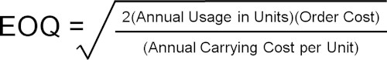

External Financing Needs

The amount of financing that you must raise in order to meet the total amount of investments that you have to make per your forecasted financial statements. This usually starts with a forecast of what your revenues are expected to be in the next year. If you forecast increases, then you have to have sufficient capacity, facilities, people, and other resources to meet this forecasted revenue target. Once you have forecasted your total assets, then you have to balance this against your liabilities and equity. If you fall short in terms of the accounting equation; i.e. you do not have enough liabilities and equity to finance your total assets, then you will have to plan for more external financing. External Wiki Page

Financial Plan

A complete plan for describing the how financial resources will get applied and ultimately result in financial results for a forecasted period of time. This would include a set of forecasted financial statements and budgets that describe the required investments and funding for different business units or segments. For example, there are requirements for business divisions such as Marketing, Production, Engineering and Administration. Each has an Operating Budget that is part of the overall Financial Plan. External Wiki Page

Financing Cost

The total cost you incur to raise external capital from lending institutions such as banks. A good example of financing cost is interest you must pay on a loan. You might also incur processing fees and special requirements such as compensating balances to ensure you can pay back the loan. All of these costs represent financing cost.

Fixed Cost

Costs that have been invested into the business and they will not change regardless of how much volume of business you experience. These costs are fixed regardless of what you sell or produce. For example, you have to pay for certain administrative personnel to maintain the business no matter how much you sell. Manufacturing companies invest heavily in tangible facilities and these costs will not vary. It is important to have a sufficient volume of business to at least cover your fixed costs. If you can’t at least cover your fixed costs, then you run the risk of becoming insolvent; i.e. you can no longer pay the basic level of costs to keep the business running through hard times. External Wiki Page

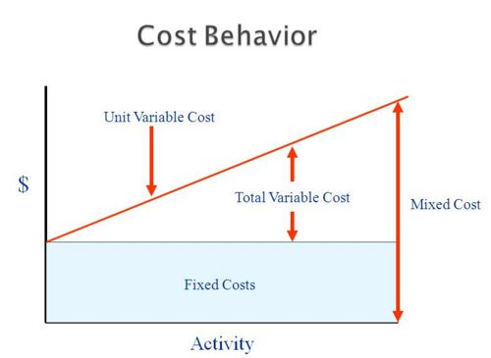

Gross Amount

Total amount before deducting some contra amount related to the gross amount. For example, the Gross Revenues before deducting any expenses is $ 3,500,000. The total expenses associated with the revenues is $ 2,300,000. The net amount is $ 1,200,000. Gross amounts often refer to total revenues, total assets or total investments before you deduct out the related costs. Other examples include Gross Payroll before deducting out taxes and other deductions or Gross Fixed Assets before deducting accumulated depreciation.

Net Amount

Gross amount less some contra amount related to the gross amount. For example, the gross amount of Fixed Assets is your total acquisition cost of $ 5,000,000. You setup a contra account to capture the depreciation of Fixed Assets. The accumulated amount of depreciation is $ 1,000,000. The “Net Amount” of your Fixed Assets is $ 4,000,000. Another example would be gross salaries less taxes and benefits equals net pay. Gross income less taxes equals Net Income. There are many examples of what might represent a Net Amount.

Operating Budget
A budget as it relates to the operations of the business such as production, engineering, marketing, research, and administrative. Operating Budgets may relate to business units, divisions or departments. Operating Budgets are formulated based on the perceived needs for an upcoming period and they determine how high level funds at the enterprise or organizational level get allocated. External Wiki Page

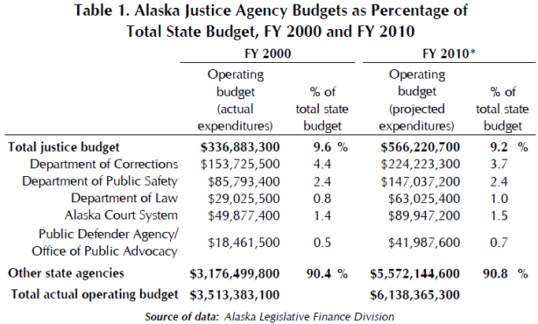

Segmentation

The sub dividing of some type of business activity such as applying the 80-20 Rule. For example, you may want to stratify your inventory into several layers or groups to distinguish which inventory items are accounting for most of your sales. Another example of segmentation is market segmentation where you would segment different markets by demographics or some customer criteria. Segmentation helps you better manage what is most important as opposed to spending all of your time and resources on things that are not important. For example, 80% of your sales revenues may be attributable to 20% of your customers. So you would want to pay careful attention to this 20% customer group. Segmentation gives you much better focus and helps you understand the different components of business activity. External Wiki Page

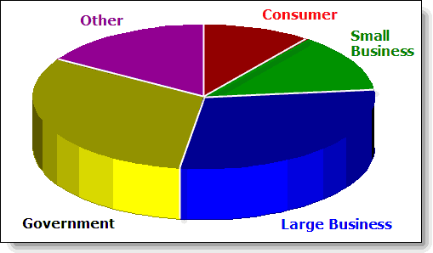

Supply Chain

An overall process that consists of major activities from sources of supply (such as labor and materials) to making and delivering products and services to the customer. Within this supply chain process involves the conversion of inputs into outputs; such as taking raw labor or materials and producing some end product that is consumed by the customer. All of the activities that comprise the Supply Chain need to work together. This requires a high degree of collaboration, communication and coordination. Some companies use formal systems to help manage the supply chain process. This can include procuring and ordering supplies as needed or tracking the shipment of goods to distribution points. All of these activities are linked and connected as part of the supply chain. External Wiki Page

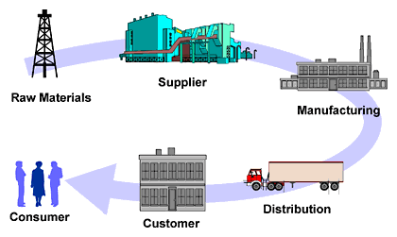

Variable Cost

Cost that vary or change with different levels of production, delivery or service. These costs are usually directly associated with serving your customers or manufacturing products. As more services or products are demanded you have to apply more direct resources to the effort (such as labor or personnel who make the products and deliver the services). As business declines, you do not need these resources. So these types of cost are variable cost.
External Wiki Page

