Glossary – Module 1 Course 2 Introduction to Financial Analysis

Accounts Receivable Turnover

A ratio that indicates the number of times you are able to convert or turn your receivables over during the year. Simply divide total sales on account for the year by the average receivable balance for the year. For example your total credit sales for the year was $ 5,400,000. The Accounts Receivable balance at the beginning of the year was $ 850,000 and at the end of the year the balance was $ 950,000. The average balance for the year was $ 900,000. The Accounts Receivable Turnover ratio is $ 5,400,000 / $ 900,000 = 6. External Wiki Page

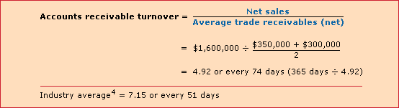

Asset Turnover

The number of times you are able to turn your total assets over into sales. The fundamental reason for investing in assets is to generate revenues or sales. So this is ratio cuts to a very basic purpose behind investing in assets. Simply divide total revenues by the average total asset balance for the year. For example, total sales revenues during the year was $ 4,500,000. The average total asset balance during the year was $ 1,800,000. The Asset Turnover rate is 2.5 ($ 4,500,000 / $ 1,800,000). External Wiki Page

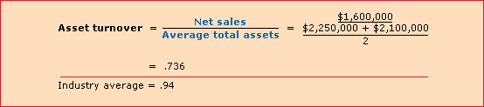

Book Value

Total costs of an asset less the accumulated depreciation. For example, you acquire equipment at a total cost of $ 100,000 and you depreciate the asset over 5 years. You record $ 20,000 of depreciation each year ($100,000 divided by 5). The book value at the end of Year 2 would be $ 60,000 ($100,000 - $ 40,000 of accumulated depreciation years 1 and 2). Book value is the amount disclosed on the Balance Sheet for those long term assets that are subject to capitalization such as Equipment or Intangible Assets which are amortized over time. Book value is sometimes referred to as Carrying Value. Book Value has nothing to do with the fair market value of the asset. When the asset is sold, the difference between the Book Value and the amount you receive for the asset is recorded as a loss or gain. External Wiki Page

Capital Turnover

The number of times you are able to turn the equity capital of a business into sales during the year. Simply divide total sales revenues by the average equity during the year. For example, total sales revenues during the year was $ 8,400,000 and the average equity balance during the year was $ 1,400,000. The Capital Turnover rate is 6 ($ 8,400,000 / $ 1,400,000).

Cost of Capital

The cost of financing the assets that a business uses to generate revenues. All assets are either financed through liabilities or equity. Each has its own cost of capital. Liabilities that are interest bearing debt instruments represent the cost of capital for liabilities. This cost of capital is reduced to account for the fact that you can deduct interest on your tax return. In the case of equity, the cost of capital is what owners expect to earn for taking the risk of investing their own money in the business. The cost of equity is higher than the cost of debt since it is much riskier.
External Wiki Page

Current Ratio

Ratio of current assets to current liabilities. The ratio should be above 1.0 to cover your current obligations. If inventories and receivables are not converted over into cash in a timely manner, then the current ratio should be well above 1.0. Each company and industry is different depending upon the composition and nature of their current assets and current liabilities.
External Wiki Page

Direct Cost

Costs that have a direct association with a specific cost object such as a department, product, business unit or project. The cost object directly consumes these resources and there is a direct relationship between what was consumed and by what cost object. A simple example is the charging of labor time to projects. People are assigned to work directly on a specific project and they charge their time to that project using a charge code. External Wiki Page

Discounted Payback

The point in time in which you begin to recover your entire investment as measured in discounted dollars. In the example below you recover your investment in Year 5 when the cumulative net present value is no longer negative and turns positive:

EBITDA

Earnings Before Interest Taxes Depreciation Amortization. EBITDA is often used as a rough indicator of a company’s operating cash flow. Many mergers and acquisitions will start by reviewing EBITDA since companies traditionally sell for a multiple of their EBITDA depending upon the revenue size of the company. In order to account for future investments and other changes to operating cash flows in the future, EBITDA is adjusted and disclosed as “Recast” EBITDA in the final merger and acquisition. External Wiki Page

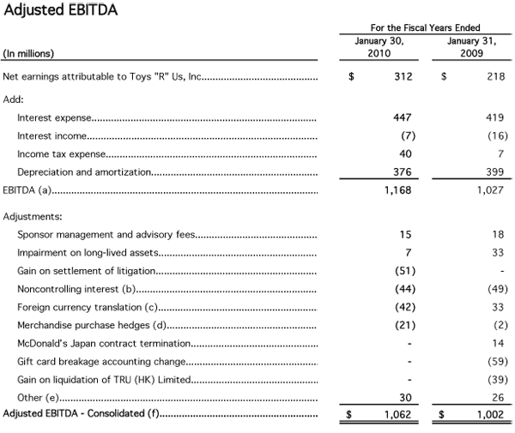

Fair Market Value

The price at which an asset sells for between a willing buyer and willing seller where both parties have reasonable knowledge about the asset. Most assets establish fair market value based on the simple fact that the asset is commonly sold in the open market. For example, automobiles and houses are openly sold between buyers and sellers who have fairly good knowledge about what the asset should sell for. External Wiki Page

Future Value

The value of what an amount will be in the future at some point in time and at some rate of return. Future values can be calculated by using a Future Value table such as the following:

For example, if you invest $ 10,000 today and you expect to sell this investment five years from now, what is the future amount if you expect a rate of return of 8%? The future value is $ 14,690 ( $ 10,000 x 1.469).

Historical Value

The amount assigned to a transaction in monetary terms based on the exchange that took place at the date of the transaction. Accounting records amounts that pass through your check book and this becomes the historical value or record for the transaction. The amount does not change over time; i.e. it is the historical amount that was posted in the accounting process.
External Wiki Page

Horizontal Analysis

A simple method of analyzing financial information by looking at several comparative periods and trying to understand the trends. By looking at the change from period to period you can gain insights into what will happen going forward. For example, if you use 2008 as your base year you can calculate percentage increases in subsequent years on your Income Statement as follows:

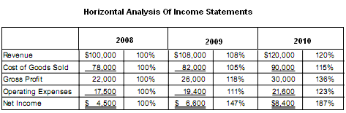

Indirect Cost

Costs that cannot be directly associated with a specific cost object such as a business unit, department, project or some cost center. Indirect costs often represent over-arching support provided to numerous cost objects. For example, the Human Resource Department provides a service of hiring new people who work on projects. The projects are not directly charges for the hiring services. It becomes part of indirect costs or overhead. Each project is allocated a portion of the overhead or indirect support costs to reflect the indirect consumption of the services provided. External Wiki Page

Inventory Turnover

A ratio that indicates the number of times inventory is turned over during the year. Simply divide the Cost of Sales or Cost of Goods Sold by the average inventory balance for the year. For example, the total Cost of Goods Sold for the year was $ 10,500,000. The inventory balance at the beginning of the year was $ 850,000 and the balance at the end of the year was $ 900,000. The average inventory balance for the year is $ 875,000. The Inventory Turnover for the year is 12 ($ 10,500,000 / $ 875,000). External Wiki Page

Liquidity

The ability of an asset to be converted into cash. For example, amounts owed to you in the form of accounts receivable are very liquid since you should collect and deposit payments within a very short period of time. Assets such as fixed structures are not very liquid since these assets may be difficult to sell. A company needs to maintain a sufficient level of liquid assets such as cash to meet its current obligations. At the same time you do not want to hold too much in liquid assets since they generate little or no return for the business. External Wiki Page

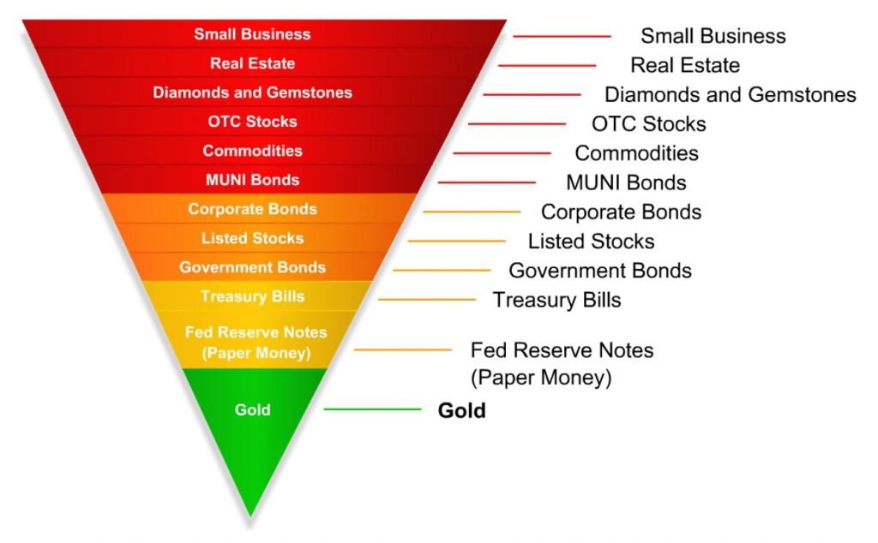

Net Present Value

The amount of value that an investment increases or decreases for a business. The value is calculated by discounting the cash outflows (costs) of the investment and the cash inflows (benefits) of the investment. This gives you a present value for the outflows and the inflows. The net of these two amounts is the Net Present Value of the investment. The discount rate applied to the cash outflows and inflows is a function of length of time involved and the cost of capital of funding the investment. The longer period of time involved, the lower the present value amount. The higher the cost of capital, the lower the present value amount. External Wiki Page

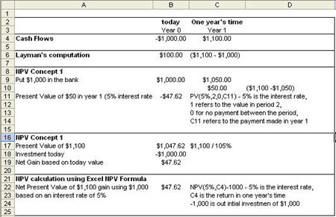

Present Value

Amounts that are forecasted into the future are discounted back to what you think the value is today. Values in the future have less value today because of the time value of money; i.e. money will lose its value over time due to things such as inflation and risk. The longer the period of time involved, the lower the present value given higher risk. In addition to time or number of periods involved, the rate you select will influence what the present value will be. Rates are selected based on what you expect the investment to return or what it will cost you to finance the investment. Discount factors are used to calculate present values based on the number of periods involved and the rate. Discount factors are listed below for periods 1 through 10 and rates 1% to 5%. For example, if you expect to realize a future amount of $ 5,000 five years from now and you want to earn 4%, then the present value would be $ 4,110 ($ 5,000 x .822).

Return on Investment

The rate that you earn on investments that you make. The residual benefits from the investment are divided by the total cost of the investment to arrive at the Return on Investment. For example, you made an investment in real estate. The investment includes total cost to acquire the property of $ 1,000,000. You also have legal fees, taxes and other costs amounting to $ 200,000. You invest an additional $ 600,000 in the property over two years. Your total amount invested is $ 1,800,000 ($ 1,000,000 + $ 200,000 + $ 600,000). In the third year, you sell the developed property for $ 2,700,000. The residual benefits from this investment are $ 900,000 ($ 2,700,000 - $ 1,800,000). If you divide $ 900,000 by the total cost of the investment of $ 1,800,000, this gives you a Return on Investment of 50%.

Solvency

The financial stability and capacity of a business to grow and sustain itself well into the future. A company that is highly solvent has an abundance of financial resources to survive through good and bad times. A company that is insolvent lacks the financial resources to sustain itself and meets its obligations. Insolvent companies are in default and usually face bankruptcy. Solvency is often measured by looking at the long term debt that a company has in relation to its assets and equity. Extremely high levels of long term debt can represent insolvency since the company can no longer service its debt load leading to default. External Wiki Page

Vertical Analysis

Expressing financial statement balances as percentages vertically down the financial statement with Total Assets = 100% for the Balance Sheet and Total Revenues = 100% for the Income Statement. You can quickly size up how the company is leveraged on the Balance Sheet and what are the significant revenues and expenses behind profitability.

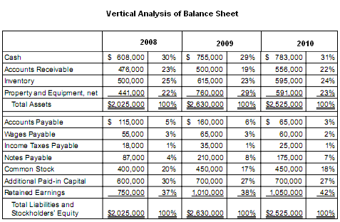

Working Capital

Current operating capital used by the business consisting of the current assets less the current liabilities. The net current assets available represents resources you can apply to current operations (such as your capacity to go out and acquire inventory).
External Wiki Page

