Glossary - Module 1 Course 1 The Basics of Accounting

Accounting Cycle

A set period of time between cut-off dates for recording transactions and generating the financial statements. Most businesses run monthly accounting cycles and produce internal financial statements. Each quarter (3 month intervals) more formal statements are generated to supported tax reporting requirements and then once a year a set of formal financial statements is generated and the accounting records are closed out. Therefore, the overall accounting cycle is typically 12 calendar months with smaller periods embedded within this overall cycle. The shortest cycle is often the payroll cycle which takes place every two weeks or bi-monthly. During this two week time frame, payroll accounting transactions are generated. The process repeats itself every two weeks and at the end of the quarterly period taxes are paid on the accumulated payroll over this three-month period. Therefore, shorter accounting cycles (such as payroll) feed the longer accounting cycles (such as quarterly tax deposits). External Wiki Page

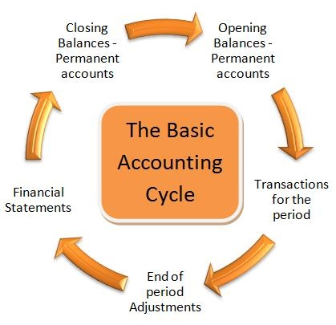

Accounting Equation

The Accounting Equation provides the framework for the Balance Sheet by compiling all accounts that have real balances into three groups: Assets, Liabilities and Equity. All assets are financed by either incurring a liability or having the owner’s invest their own money (equity). The sum of all assets must equal the sum of all liabilities and equity. This is referred to as the Accounting Equation (Assets = Liabilities + Equity). External Wiki Page

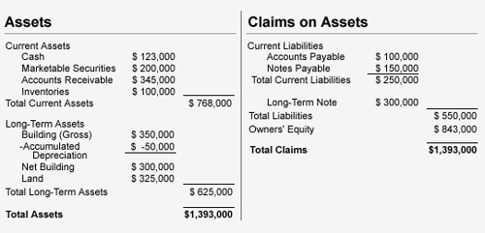

Accounting Transactions

An economic exchange requiring some form of an accounting entry. Accounting entries recognize economic exchanges in accordance with the rules and principles of accounting. Most accounting transactions tend to be cash basis; i.e. when you receive cash you post an accounting entry to increase cash and recognize the event that gave rise to the event such as Sales Revenue or Sale of Equipment. Therefore, accounting entries have two sides: Debit and Credit. All transactions must balance out such that the sum of all debits equals the sum of all credits. In addition to cash basis type transactions, you will also have transactions that do not involve cash such as recognizing a liability to pay someone in the future. A common example of this is Accounts Payable. When you consume services and receive an invoice for these services, you are obligated to pay this in the future. An accounting transaction is recorded when you receive the invoice, recognizing the expense and the Accounts Payable that must be paid.

Accrual Accounting

Accounting accrues transactions before the cash is exchanged. For example, revenues are recognized when two parties conduct business and the service or product has been delivered. Revenues are recorded at this point and later the cash transaction takes place. Likewise, an expense will get recognized when incurred even though no cash has been disbursed yet. Some accrual entries may not involve cash, such as accruing depreciation expense on an asset or accruing a contingent liability that you may or may not have to pay at some point in the future.
External Wiki Page

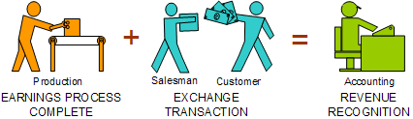

Adjusting Entry

An accounting entry posted for the purposes of ensuring that the accounting records are in compliance with various accounting principles and rules. For example, accounting is based on the accrual concept whereby you must accrue all expenses you incur. At the end of the accounting cycle, you may have incurred some taxes that must be paid. You need to post an adjusting entry to accrue these taxes to ensure what you report follows the accrual basis of accounting.
External Wiki Page

Assets

Economic resources of a business which are applied for the main purpose of generating revenues; i.e. businesses make investments with the expectation of creating revenues and if revenues exceed costs, then the business has a profit. This is one of the main goals behind every business. Assets are further divided into Current and Long-Term. Current Assets are consumed or converted into another asset within the normal operating cycle of the business which is often considered to be one year. If the asset will not be converted into another asset within one year, then it is classified as Long Term. Examples of current assets include Cash, Marketable Securities, Accounts Receivable, Notes Receivable, and Inventory. Examples of long-term assets include Equipment, Property, Land, Buildings, Long Term Investments, Patents, Trademarks, and Goodwill. External Wiki Page

Chart of Accounts

Before you can start posting accounting transactions, you need to setup a Chart of Accounts for each account you will use within your accounting process. For example, if you have plans to invest in Real Estate, then you should setup an account for this asset. Most businesses require some basic accounts such as Cash, Accounts Receivable, Accounts Payable, Owner’s Equity or Capital, and Retained Earnings. You also need a good set of accounts on how you want to classify the costs you expect to incur, such as Cost of Services or Cost of Goods Sold, Marketing and Selling Expenses, and General Administrative Expenses. External Wiki Page

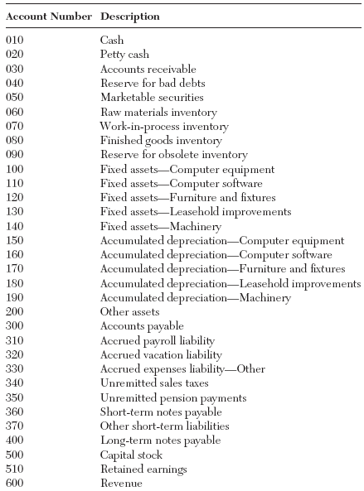

Closing Entry

An accounting entry that is made at the end of an accounting cycle for the purpose of closing account certain accounts in order to properly report the financial results of the business. A very common example is closing out the nominal accounts that comprise the Income Statement. The residual balance remaining from all of these nominal accounts is closed out to the Retained Earnings account.

Comprehensive Net Income

The concept of recognizing certain types of economic events as part of the calculation of Net Income that otherwise is not recognized on the Income Statement. For example, you may have unrealized gains from holding currencies in other countries, but the Income Statement does not recognize these gains. Comprehensive Net Income picks up these economic events to better represent the economic reality of what is taking place.

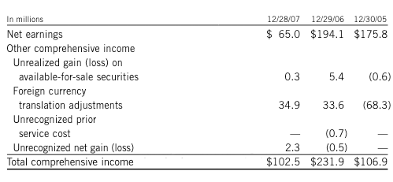

Consolidated Financial Statements

The combination of separate entities, business units or companies that are all consolidated together to report the financial results of the larger parent organization. Larger companies are often broken down into smaller companies, many of whom operate in different businesses. The overall results of the larger company must be reported in the form of consolidated financial statements. When preparing consolidated financial statements you may have to make certain adjusting entries such as inter-company transactions; i.e. the smaller companies are conducting business between themselves and a receivable on the books of one company may be an accounts payable on the books of another company.

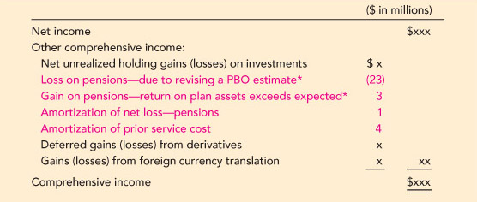

Contra Accounts

An account setup to offset another account so that you can report a net balance for the combination of the two accounts. A good example is Accumulated Depreciation which is a contra account offsetting the Fixed Assets account which accumulates total acquisition costs of assets. When you combine the two accounts, you report Net Fixed Assets (Fixed Assets less Accumulated Depreciation). External Wiki Page

Control Accounts

A few general ledger accounts require several detail fields to properly manage the large volume of transactions that flows through the account. For example, a utility company has thousands of customers that get invoiced for electricity. This creates an accounts receivable entry for every customer. In order to properly control all of these transactions, the Accounts Receivable account has its own sub-ledger within the accounting system that further breaks down the account into customers and every invoice that is outstanding. From the Accounts Receivable Sub Ledger you can run an Aging Report to see which customers have not paid their invoices in over 30 days. Control Accounts are very common for receivables, inventory, work in progress, and payables.

Cost Principle

One of the basic principles of accounting is to recognize all of the costs associated with acquiring and placing the asset into service. For example, the construction of a new building requires a survey, inspection, design and a lot of preliminary work before actual construction begins. All of these costs become part of the basis for depreciating the asset. In the event that non-cash is exchanged to acquired an asset, then the fair market value of the asset you surrendered becomes the cost basis.

Debits and Credits

Accounting entries are posted in terms of both a debit and a credit entry. For every debit entry, there must be at least one corresponding credit entry. The sum of all debits and credits must equal. Depending upon which type of account, each account has a normal balance that is either a debit or credit. External Wiki Page

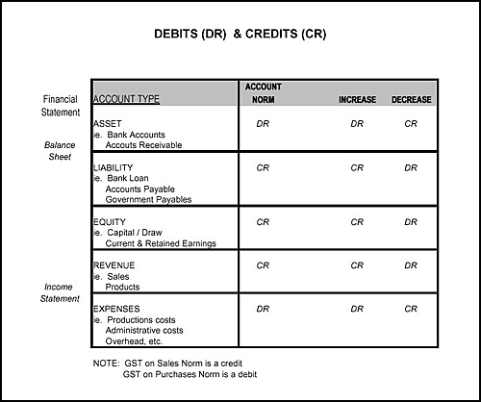

Deferred Expenses

An expense that initially gets recorded as an asset since it is deferred into the future; i.e. the expense does not get recognize until later. For example, prepayment of rent or insurance would give rise to a deferred expense or asset. External Wiki Page

Deferred Revenues

A revenue item that does not get recorded as revenue initially since it has not been earned yet. For example, if a customer pays you in advance of getting a product or service, you may have to recognize the advance as deferred revenues or a liability. Deferred revenues are unearned until you later delivery the service or products. External Wiki Page

Equity

Amounts invested by the owners of the business. Equity also includes Net Income that the business has decided to retain for re-investing back into the business as opposed to distributing back to the owners. Equity ownership for publicly traded companies is represented by stocks which are traded on public exchanges such as the New York Stock Exchange. The term “Net Assets” is sometimes used to describe Equity by simply stating that the Assets less Liabilities = Net Assets (Equity) of the business. External Wiki Page

Financial Statements

At least three financial statements are prepared for a business: Balance Sheet, Income Statement and Statement of Cash Flow. The Balance Sheet summarized the financial condition of a company in terms of its assets, liabilities and equity. The Income Statement reports the profitability or loss for a company over a certain period of time. The Statement of Cash Flow describes the cash inflows and cash outflows in terms of operating activities, investment activities and financing activities.
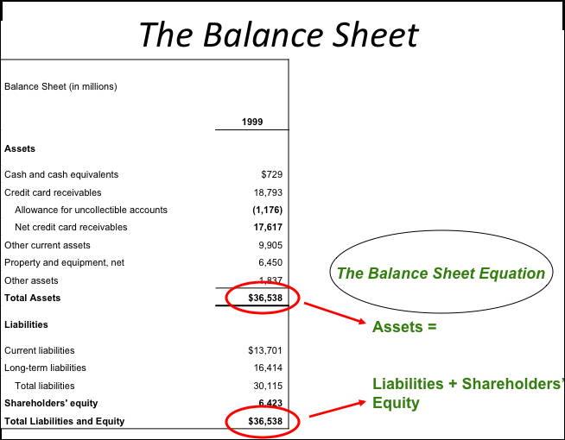
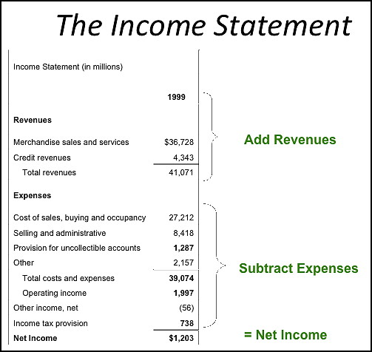
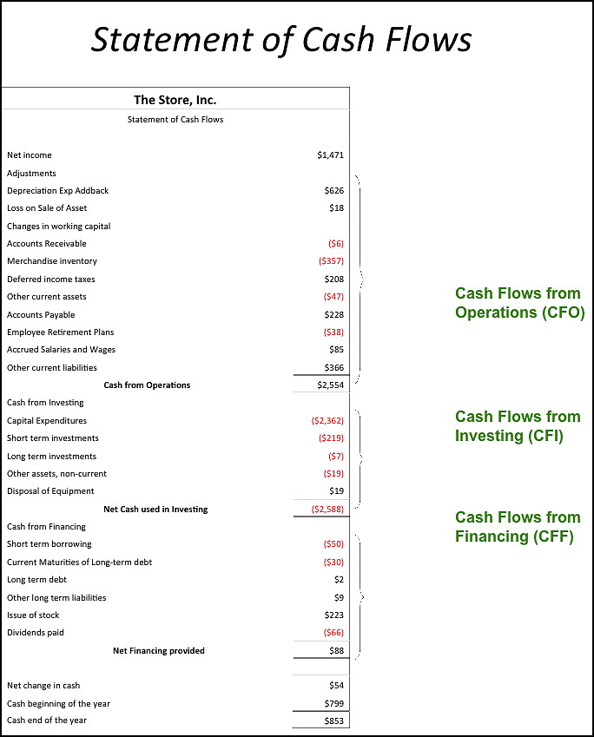

Full Disclosure Principle

In order to properly disclose all relevant economic information about a business, you must go beyond a set of financial statements. For example, background information about a major transaction should be explained as part of the footnotes within the financial statements. Supplemental schedules can help explain what comprises an account reported on the financial statement. Under segmental reporting you should disclose business units, customers or other entities that contribute 10% or more of your revenues. Sufficient information must be provided so that investors and other users of the financial statements can make informed decisions about the business. External Wiki Page

GAAP

In the United States, the complete set of rules or principles that you should follow for accounting is referred to as Generally Accepted Accounting Principles. Some of the principles are broad and apply to all types of businesses such as Revenue Recognition whereas other principles may be more industry specific such as how to recognize costs when exploring for oil and gas.
External Wiki Page

IFRS

International Financial Reporting Standards is similar to GAAP, but it applies to companies in over 80 countries. This is important since more and more companies exist in a global economy and there is a need for one common set of principles that all companies regardless of location should follow. As a result, more and more countries including the United States are changing their accounting rules and practices to align to the IFRS. External Wiki Page

Income Summary

A special type of account used to close out the Income Statement to Retained Earnings. All revenue and expense account balances are cleared out by transferring what-ever the balance is to the Income Summary account and then what-ever remains as the balance in the Income Summary account is transferred to Retained Earnings.

Inventory Costing

Inventories carry costs according to a flow principle such as FIFO, LIFO or Weighted Average. Under FIFO – the first units of inventory that you acquired are the first units that you ship or deliver to the customer when a sale is made. Under LIFO, the most recent or last units you bought are the first units taken out of inventory. And under weighted average, you would calculate a weighted average cost for your entire inventory to arrive at the unit cost you would charge Cost of Goods Sold when inventory is sold.

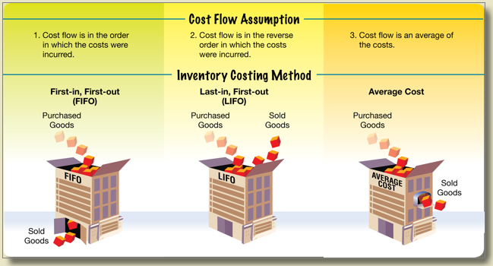

Liability

An outstanding obligation that must be met in the future requiring the disbursement of cash or transfer of other assets. Liabilities represent claims that others have the right to make against your business. Short term liabilities are due within the current year and they often represent amounts you owe to vendors, suppliers and other third parties. These liabilities typically are accrued to the Accounts Payable account. You also have current obligations to pay your employees which may get accrued under the Salaries Payable account. Some other current liabilities include taxes, interest, rent, and utilities. Long term liabilities often involve loans and debt. Contingent liabilities are accrued since there is a probability that you will incur some kind of loss depending upon the outcome of an event. Businesses need to fully recognize the full scope of their liabilities and if the liability cannot be measured and accrued, you should at least disclose the liability in the footnotes to the financial statements to properly inform investors of these claims against your business.

Matching Principle

Expenses are recognized as revenues are recognized; i.e. you will match up the related expenses associated with those revenues that have been earned. A common example of this is to recognize all of the costs associated with the inventory that you sold. For example, you sold 10,000 units of inventory and you should recognize the Cost of Goods Sold for these 10,000 units. In other cases you will match the appropriate accounting period to recognize the appropriate amount of the expense. For example, you may have paid for 3 years of insurance, but you will recognize and expense only 1 year during the first year. The other two year’s of insurance will be classified as a Prepaid Insurance asset. If there is no clear distinction on how to recognize expenses, then you should consider taking a conservative approach of expensing the item unless the costs incurred are reasonably material and provide some future benefit to you over several years such as the purchase of equipment. External Wiki Page

Multi Step Income Statement

Due to some unusual items, the Multi-Step Income Statement distinguishes normal revenues and expenses from unusual items or adjustments that get disclosed below the normal recurring type items. This helps the user focus better on results from normal business as opposed to being somewhat misled by unusual items within the Single Step Income Statement.

Net Realizable Value

The amount that you realize as income after all of the costs to dispose or sell the asset. Assets may have a sales price, but there are direct costs to sell the asset. The sales price less the direct costs of selling the asset is the net realizable value. For some assets such as Accounts Receivable, you may setup an Allowance for Bad Accounts to recognize the fact that you may not collect all of your receivables; i.e. a few customers never pay. The total amount of accounts receivable less the allowance for bad accounts is the net realizable value for all of your receivables. External Wiki Page

Nominal Accounts

General ledger accounts that carry a balance for a certain period of time are referred to as nominal accounts. Most of the nominal accounts relate to the Income Statement since these accounts are closed out to Retained Earnings. Therefore, all nominal accounts at some point in time will have a balance of $ -0-.

Paid in Capital

Companies that issue stock set the value of the stock at par value. Par value tends to be somewhat arbitrary and the total price that is paid for the stock may be well above the par value. This additional amount that is paid above par value is Paid in Capital or Additional Paid in Capital or Paid in Capital in Excess of Par Value. Common Stock shown in the equity section of the Balance Sheet is reported at par value. External Wiki Page

Prior Period Adjustments

Special accounting entries that are made to correct a mistake from a previously reported period. A special account is often setup to disclose prior period adjustments since this may have to be reported as part of the Statement of Retained Earnings. Errors that require prior period adjustments include making a mistake in how you calculated depreciation or posting an entry to a wrong account.

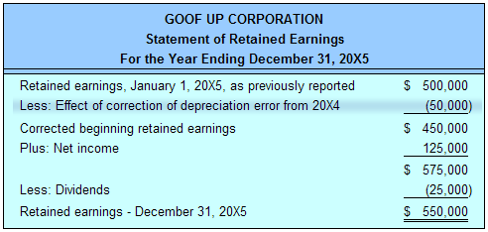

Real Accounts

General ledger accounts that always carry a balance at any given point in time. Most of these real accounts represent the accounts that make up the Balance Sheet. Examples include Cash, Accounts Receivable, Inventory, Accounts Payable, Loans Payable, Owners Capital and Retained Earnings.

Revenue Principle

All revenues are recognized when the earnings process is complete which involves an arms length transaction and a basis for measuring and collecting the revenues that have been earned. For example, an Engineering Company will issue progress billings to a client as work progresses. If the work is 30% complete, the Engineering Company will invoice 30% of the total contract value to the client. These revenues have been earned and the Engineering Company should recognize these revenues based on the expectation of getting paid. In other cases, a company recognizes revenues when the services or products are delivered and title (ownership) passes to the customer. External Wiki Page

Single Step Income Statement

Simple approach to disclosing all revenues together and all expenses together to arrive at Taxable Income or Net Income.

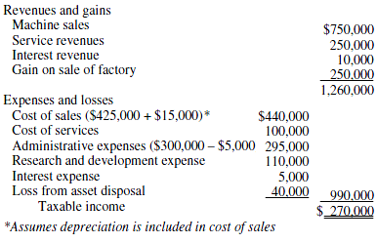

T Account

General ledger accounts can be viewed in terms of a “T” with the title of the account across the top and the left side showing each debit entry and the right side showing each credit entry.

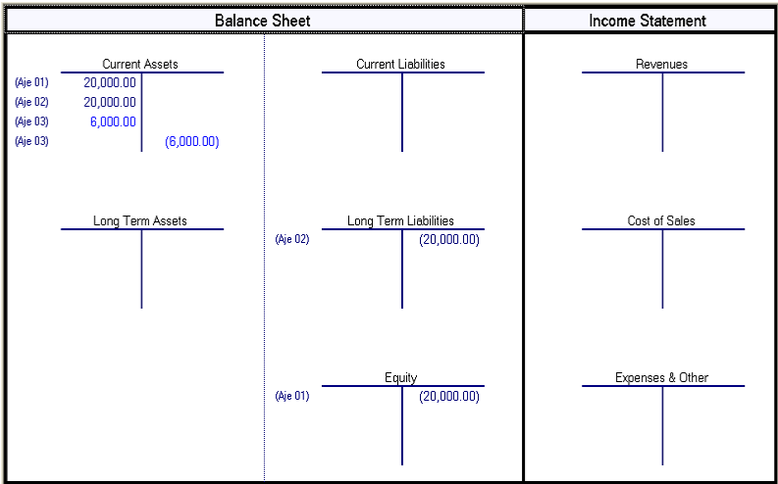

External Wiki Page

Trial Balance

At the end of each accounting period it is useful to capture all of the balances for your general ledger accounts. After you collect all of the balances, you probably will need to make some accrual entries or adjusting entries. For example, if you have equipment then you should post a depreciation expense entry. Once you complete all entries you can then pull off the balances you need to report on your financial statements directly from the Trial Balance. External Wiki Page

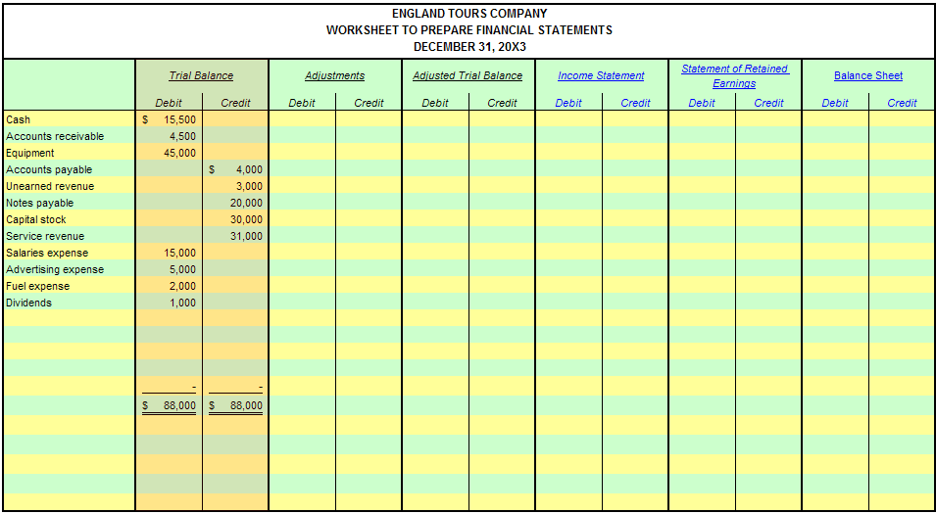

Work in Progress

A special kind of current asset account that is used to help control projects, inventory or other assets that are under construction. In the case of Engineering Companies, projects are invoiced out to clients and thus the Work in Progress account gets cleared to Accounts Receivable as work gets done and billed to the customer. In the case of Utility Companies, projects to construct new power stations accumulate costs within Work in Progress and when the asset is placed into service, all accumulated costs are transferred to Plant Equipment. External Wiki Page

